|  |
| --- |
|  |
| Smart Green House Effect  EMBEDDED SYSTEM DESIGN & APPLICATION PROJECT |
| |  |  |  | | --- | --- | --- | | ENGR. NOMAN AHMED SIDDIQUI | ELECTRONIC ENGINEERING DEPARTMENT | SIR SYED UNIVERSITY OF ENGINEERING & TECHNOLOGY | |

**SMART GREEN HOUSE**

**MONITORING & CONTROL SYSTEM**

**EMBEDDED SYSTEM DESIGN & APPLICATION (EE_340)**

**Submitted by**

**MUHAMMAD HASSAN 2017-EE-069 AAZIB AHMED ANSARI 2017-EE-078**

**MIRZA HAMZA UMER 2017-EE-079**

**MUAMMAD USMAN 2017-EE-107**



**7th Semester Project Report**

Department of Electronic Engineering

Sir Syed University Of Engineering and Technology, Karachi

**ACKNOWLEDGEMENT**

We would like to express our deepest appreciation to all those who provided us the possibility to complete this project and report.  A special gratitude we give to our project  teacher, **ENGR.NOMAN AHMED SIDDIQUI,** whose contribution in stimulating suggestions and encouragement,  helped me to coordinate our project especially in writing this report.

Furthermore we would also like to acknowledge with much appreciation the crucial role of **ENGR. SHAHRUKH** who gave the guidance to in our project and the necessary materials to complete the project. A special thanks goes to my Group Members who help me to assemble the parts and gave suggestion about the task .Last but not least, many thanks go to the head of the project, whose have invested his full effort in guiding the team in achieving the goal. I have to appreciate the guidance given by other supervisor as well as the panels especially in our project presentation that has improved our presentation skills thanks to their comment and advices.

**TABLE OF CONTENTS**

**Page**

**Acknowledgment** 02

**Table of Contents** 03

**List of Figures**  04

**List of Tables** 04

**Abstract** 05

1. **INTRODUCTION**

1.1 Introduction 05

1.2 Green House Effect 05

1.3 Problems and Solutions 06

1.4 Theoretical Background 06

1. **PROJECT BLOCK DIAGRAM**

2.1 Block Diagram 07

2.2 Description of Blocks 08

2.3 Design specification 09

1. **METHODOLOGY**

3.1 Hardware Working 10

3.2 Software Working 10

1. **TESTING**
   1. Hardware Testing 10
   2. Software Testing 11
2. **OBSERVATIONS & RESULTS** 11
3. **CONCLUSION & FUTURE RECOMMENDATION** 12

**REFRENCES** 13

**APPENDIX A: Cost Analysis of the Project** 14

**LIST OF FIGURES**

**Page**

Figure 1.1 Green House Effect  06

Figure 2.1 Block Diagram of Circuit 07

Figure 2.2 Pin Configurations 08

Figure 2.3 Pictures of some sensors 09

Figure 5.1 Observations & Results 11

**LIST OF TABLES**

**Page**

Table 1.1 Threshold Values  07

**ABSTRACT**

This Project represents the need of Greenhouse and how much effective they can be in good yield of crops. As plant grows, they need certain environmental parameters for its proper growth like humidity, temperature, light. Also, Automated Greenhouse Monitoring ignores the need of human operators to take care of the plants. To monitor the Greenhouse parameters like temperature, soil moisture and light properly, a control system is needed. This control system is comprised of greenhouse data acquisition PIC Micro-Controller along with temperature, and light. For monitoring and storing the values of these environmental parameters based circuit is used. Based on the values stored, the above system will compare the stored values with threshold values set for particular plant and control the actions of cooler, heater, and water pump. Greenhouse monitoring and control software can collect, values of various parameters, also can control greenhouse environment. For indication of system, we have used RED & GREEN LED’s. This system is very useful for proper cultivation and maximum yield of crops.

**INTRODUCTION**

* 1. **Introduction:**

A greenhouse is a building in which plants are grown for commercial or research purposes. These structures range in size from small sheds to very large buildings, with different types of covering materials, such as a glass or plastic roof and frequently glass or plastic walls. But, nowadays, the rising demands for crop production and quality have significantly increased the utilization of high quality and productivity of greenhouse.

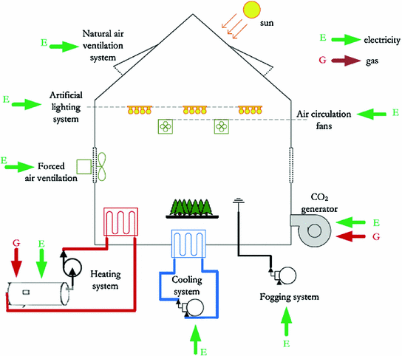

**FIGURE 1.1 GREEN HOUSE EFFECT**

The proposed system is an embedded system which will monitor and control the microclimatic parameters of a greenhouse on a regular basis round the clock for cultivate

on of crops or specific plant species which could maximize their production over the whole crop growth season and to eliminate the difficulties involved in the system by reducing human intervention to the best possible extent using sensors. When any of the above mentioned climatic parameters cross a safety threshold which has to be maintained to protect the crops, the sensors sense the change and the PIC MICRO-CONTROLLER reads error and then try to make it stable again. The PIC MICRO-CONTROLLER algorithms then performs the needed actions by employing relays until the strayed-out parameter has been brought back to its optimum level. Since a PIC MICRO-CONTROLLER is used as the heart of the system, it makes the set-up low-cost and effective nevertheless. As the system also employs a LED’S display for continuously alerting the user about the condition inside the greenhouse, the entire set-up becomes user friendly.

**1.2 Problem and Solution Encountered On Green House**:

Irrigation is the important thing on a greenhouse system. The water we provide, which is the main element will make sure the plants survive on certain circumstances. As we all know, most of the gardener use the manual system to irrigate their plant but this system is not efficient. The plants will either die if there is not enough water supplies to the plant or vice versa. Plus the gardener must often monitor their greenhouse to ensure the conditions of their plant are in the good health. In order to maintain the condition and overcome the problem, the automatic watering system and remote monitoring is used. This will reduce the time if using automatic rather than manual way of watering. Fewer workers are needed to maintain the plants or crops. The sensors such as temperature sensor (Thermistor) and soil moisture probe are used to control the temperature and watering in the greenhouse.

* 1. **Theoretical Background:**

The greenhouse system is complex system; any significant change in one climate parameter could have an adverse effect on another climate parameter as well as the development process of plants. Therefore, continuous monitoring and control of these parameters is required for the proper growth of plants. Temperature, light intensity, soil moisture are the most common factors that most growers pay attention to. So now a day’s farmers require more user friendly platform to deal with issues that arise due to climate changes. Previous researchers have used sensors such as leaf temperature and leaf wetness sensor in conjunction with ambient temperature sensor and humidity sensors to investigate greenhouse’s status.

**TABLE 1.1 THRESHOLD VALUES:**

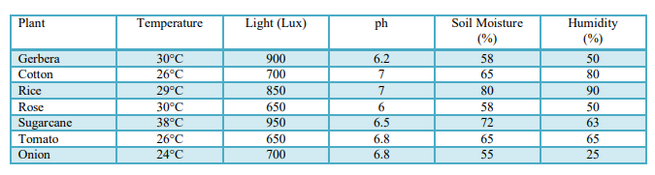

These methods were found to be impractical as wetness varies from leaf to leaf and by location of plant in greenhouse. In general the greenhouse system can be divided into two main components that interact in more or less strong way: internal atmosphere and soil conditions. Most of the growers and researches are interested in internal atmosphere of greenhouse and often neglect the importance of soil conditions. The absorption and transportation of water and nutrients are dependent on the condition of soil. Therefore it is very essential to maintain the temperature and moisture level in the soil at an optimum level in order to keep the plant healthy.

**PROJECT BLOCK DIAGRAM**

* 1. **Block Diagram:**

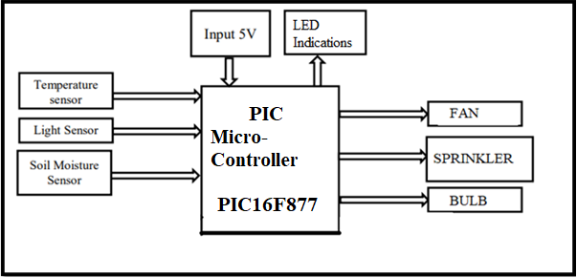

**FIGURE 2.1 Block Diagram of the circuit**

**2.2 Description of Blocks:**

**HARDWARE DESCRIPTION**

1. **PIC MICRO-CONTROLLER**

PIC MICRO-CONTROLLER are used in automatically controlled devices. For Greenhouse effective management, here in our project.

1. **Sensor:**

Sensor is a device which is used to convert physical quantity into electrical signal. A sensor is a device, which responds to an input quantity by generating a functionally related output usually in the form of an electrical or optical signal.

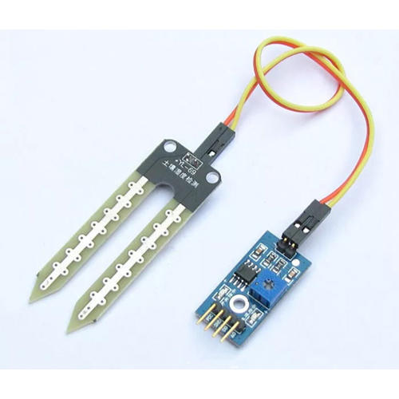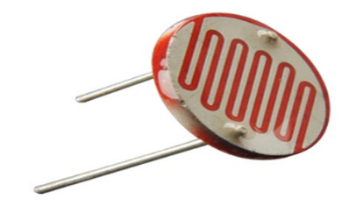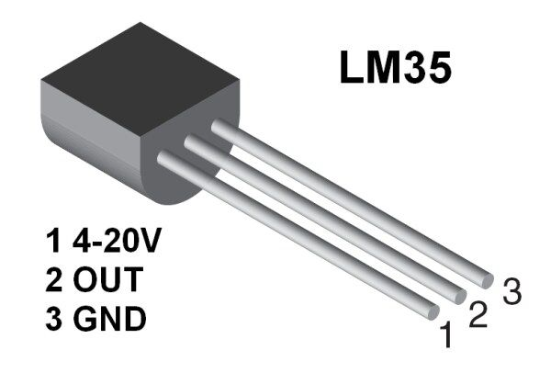**LIGHT Sensor (LDR) Temperature Sensor (LM35) Soil Moisture Sensor (FC-28-D)**

**FIGURE 2.3 PICTURES OF SENSORS**

**2.3 Design Specifications:**

**Input side - Sensors:**

1) Temperature (LM35D)

2) Light (LDR)

3) Soil Moisture (FC-28-D)

**Output side**

• Lower Temperature & decrease humidity: Cooling Fan

• Increase lighting condition: Light-bulb

• Sprinkler for increase in soil moisture.

• Constant monitoring through LED’S

**METHODOLOGY**

**3.1 HARDWARE WORKING (Controlling):**

It mainly consist of following blocks:

**1. Sensors:** we are going to use temperature sensor, humidity sensor and light sensor to sense temperature humidity and light respectively. Metal thin rods or wires are used to sense soil moisture. These sensors sense the parameters and gives corresponding voltage output.

**2. Amplifier:** As the voltage output from the sensors is in miliVolts, it has to be increased to 0 to 5 volts range. We are going to use linear amplifier for this purpose.

**3. ADC:** The main part of our project is microcontroller which reads only digital input. (0V & 5V) But the output of Amplifier is in analog form, so it has to be converted into digital format, for this purpose we are going to use ADC to convert analog output from amplifier into the digital output to be given to microcontroller

**4. Microcontroller:** This is the CPU (central processing unit) of our project. We are going to use PIC microcontroller (P16F877). The various functions of microcontroller are like:

I. Reading the digital input from ADC which is derived from Temperature and Light sensor. II. Sending this data to LCD so that the person operating this project should read the values of temperature and light. III. Controlling the parameters like Temperature, light, turning On/Off the respective relays IV. Sending the values of temperature and light to the computer using serial port

5. First one will be turned on when the temperature goes above the desired value. And the second relay will be turned on when humidity goes above the desired value. (e.g. if the desired value of temperature is 35 degree C and for humidity it is 50%, then Relay 1 will be turned on when temperature is 36 or above and Relay 2 will be turned on when humidity is 51 or above)

**6. DC Motors:** We are going to use two 12 volt DC motors. First DC motor will be turned on when Light goes above threshold level. Second DC motor will be turned on when Soil moisture goes below threshold level.

**3.2 CODING:**

// End LCD module connections

double source=0;

double temp=0;

double val= 0;

double mV,ActualTemp = 0;

void main()

{

TRISC = 0x00;

PORTC = 0x00;

ADC_Init(); // Initialize ADC

while(1)

{

source=Adc_Read(1);

if(source>600)

{

RC0_bit = 1; //motor on

RC1_bit = 0;

}

if(source<=600)

{

RC0_bit = 0; //motor off

RC1_bit = 0;

}

temp = Adc_Read(0);

mV = temp*5000.0/1023.0;

ActualTemp = mV/10.0;

if(30 > ActualTemp)

{

RC2_bit = 0;

RC3_bit = 0;

}

if(30 < ActualTemp)

{

RC2_bit = 1;

RC3_bit = 0;

}

val = Adc_Read(2);

if(val>150)

{

RC4_bit=0;

}

if(val<150)

{

RC4_bit=1;

}

}

}

**4.TESTING**

**4.1 Software Testing:** In Software testing, we used Proteus 8 for virtual simulation of various sensors with respect to the PIC MICRO-CONTROLLER. Proteus is very user friendly electronic circuit design software which can be used for circuit design, virtual simulation. We interfaced the sensors with the controller, to observe the monitoring and control actions. According to the thresholds set by the help of resistors we observed the related control actions that should have taken place in real time.

* 1. **Hardware Testing:** In hardware testing we opted for breadboard.In breadboard testing we checked the power supply output, all the results were positive and we got 5V at the output. We interfaced 3 sensors namely temperature (LM35), LDR and soil moisture (FC-28-D) on breadboard with OP-AMPS to check the monitoring and control actions. For testing purpose we used LED’s to detect whether the control actions are being performed correctly or not. The results that we achieved from breadboard testing were satisfactory and convincing. Whenever the temperature went beyond the predefined threshold range, the (RED) LED glowed, whenever temperature went below threshold range, the (green) LED glowed. (RED) LED glowed when light intensity went below the threshold while (RED) LED glowed when the soil moisture level went below the defined threshold. With the controlling actions continuous monitoring of 3 parameters was monitored by these leds LED’S.

**5. Observations & Results:**

**5.1 Results:**

 We tested our circuitry on general bean plant and got positive results out of it. Our system worked according to the threshold values for various parameters set by us..

**FIGURE 5.1 RESULTS**

**6 Conclusions & Future Recommendations:**

**6.1 Conclusions:**

The present study provides a reliable Greenhouse Monitoring and Control System, having wide application in agriculture. In this system the sensor side acts like a data acquisition unit that is capable of measuring 3 main different parameters like temperature, light, soil moisture. The main part is the PIC MICRO-CONTROLLER controller which carries out various tasks like greenhouse climate adjustment. Also, the database of various plants which is already stored in our system containing the necessary climatic conditions needed for proper growth of those plants will be very useful in increasing yield of crop plants. Thus the proposed system providing real time application and is beneficial for farmers of many developing countries like Pakistan

**REFRENCES**

**[1]**[https://neelpmehta.wordpress.com/analog-PIC Micro-Controller-control-using-op- amps/?fbclid=IwAR21gfcrOejXRKZkJPOSoin9geFHaMaxskdBxyx_7v5IlXw8UJg9p59MAWM](https://neelpmehta.wordpress.com/analog-pid-control-using-op-%20%20%20%20amps/?fbclid=IwAR21gfcrOejXRKZkJPOSoin9geFHaMaxskdBxyx_7v5IlXw8UJg9p59MAWM)

**[2] Book: Muhammad Ali Mazidi, Janice GillispieMazidi, Rolin D. McKinlay**

“The PIC MICRO-CONTROLLER & Embedded Systems”, Pearson Education Inc. 2nd Edition, 2008. pg. 123-138

**[3] Conference Paper from the Internet**

Stipanicev D., Marasovic J., “Network Embedded Greenhouse Monitoring and Control”, Proceedings of 2003 IEEE Conference on Control Applications, Vol.2, June, pp.1350-1355, 2003. [Online]. Available: IEEE Xplore, http://www.ieee.org. [Accessed: 10 Sept. 2010].

**[4] Whole Internet Site**

[1]<http://aggie-horticulture.tamu.edu/ornamental/a-reference-guide-to-plant-care-handling-and-> merchandising/light-temperature-and-humidity

[2] <http://www.vellag.com/index.php/articles/what-plants-require-for-growth>

[3] <http://www.controlledenvironments.org/Growth_Chamber_Handbook/Ch03.pdf>

[4] For pH circuit- [www.66pacific.com/ph/simplest_ph.aspx](http://www.66pacific.com/ph/simplest_ph.aspx)

[5] Marshall R. Hafercamp, “Environment factors affecting plant Productivity”, Fort Keogh research symposium, pp.27-36, 1987.

**For more material type visit:** <https://libguides.murdoch.edu.au/IEEE/all>

**APPENDIX-A**

**COST ANALYSIS OF THE PROJECT**

|  |  |  |  |  |
| --- | --- | --- | --- | --- |
| **MAJOR EQUIPMENT SPECIFICATION & COST** | | | | |
| **S.No** | **Component Name** | **Description** | **QTY** | **Cost** |
| **1** | **P16F877** | **PIC MICRO-CONTROLLER** | **1** | **250** |
| **2** | **LM-35** | **Temperature** | **1** | **35** |
| **3** | **FC-28-D** | **Soil Sensor** | **1** | **300** |
| **4** | **DC FAN** | **Cooling Fan** | **1** | **150** |
| **5** | **WATER PUMP** | **Sprinkler** | **1** | **350** |
| **6** | **LED LIGHT** | **System Display** | **1** | **40** |
| **7** | **LEDS** | **For random purpose** | **10** | **30** |
| **8** | **PUSH BUTTON** | **Reset** | **2** | **20** |
| **9** | **Structure** | **Structure** | **-** | **400** |
| **Total Cost of the Project** | | | | **1580/=** |